SOLID Principals

Solid Principals are the design Principals that enable us manage most of the software design problems

5 principles make software design more understandable, flexible, maintainable

S: Single responsibility principles

O: Open closed principle

L: liskov substitutional principle

I: Interface segregation principle

D: dependency inversion principle

Single responsibility principles:

A class should have only one reason to change

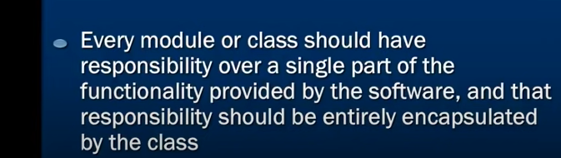

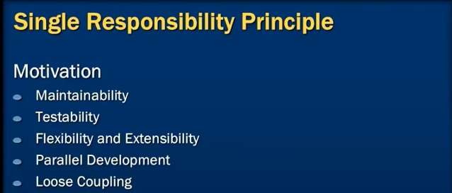

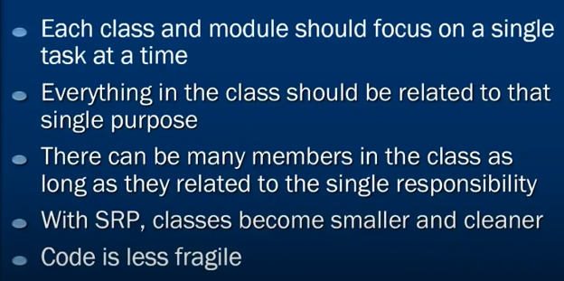

Example: 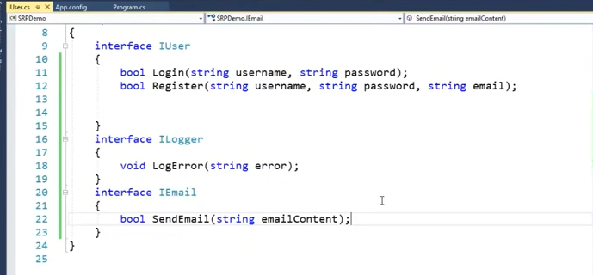

**liskov substitutional principle:**

Object in a program should be replaceable with instances of there subtypes without altering the correctness of that program

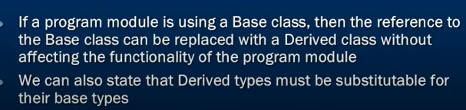

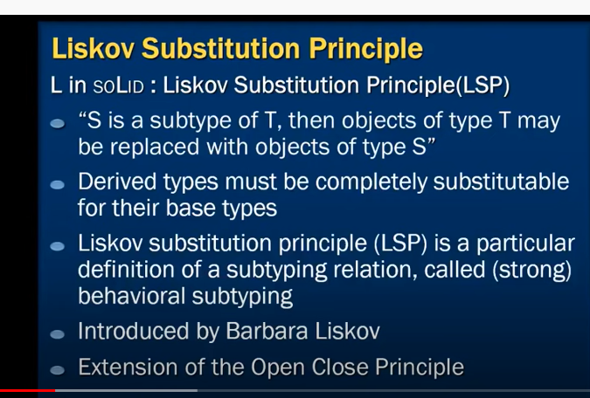

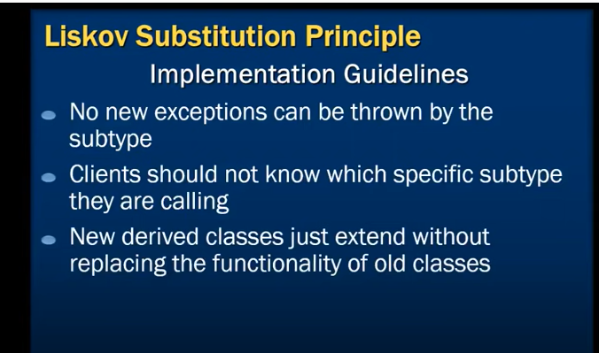

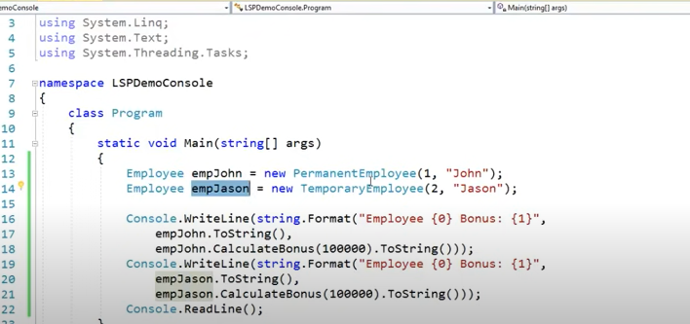

We wane partically implemented the liskov sustutinal princpl

Read the word partically because :this is not following the guidelines g LSP why?:

Ponit to note here below program contract emp is not eligible for bonus so we created exception

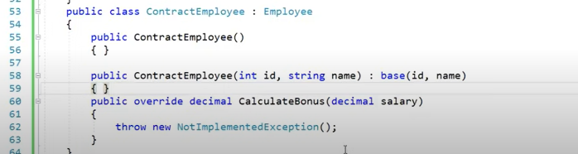

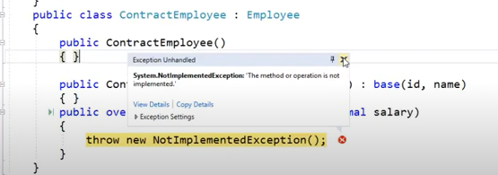

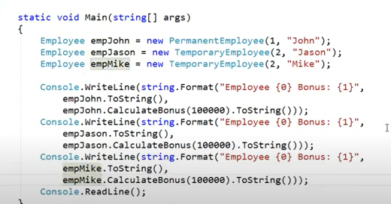

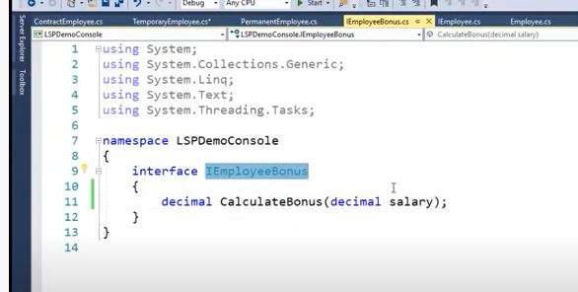

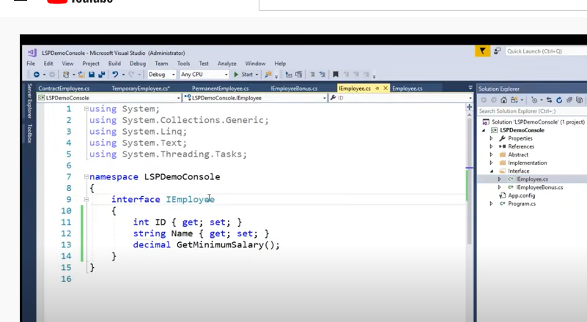

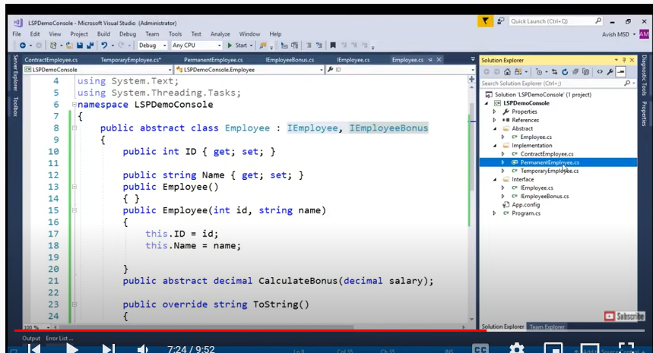

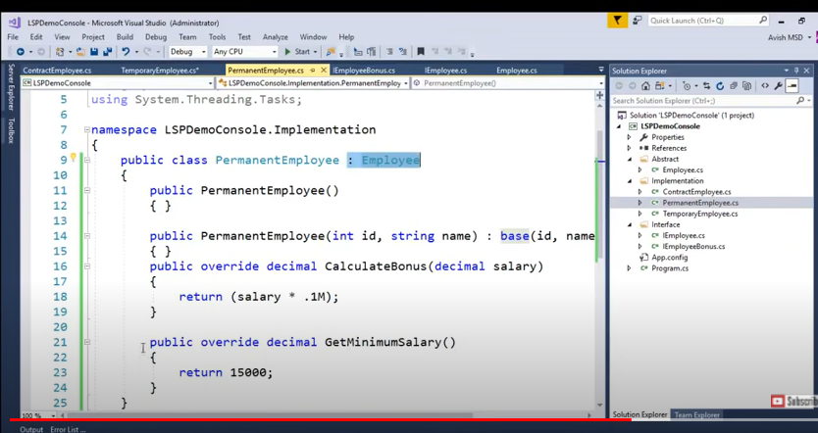

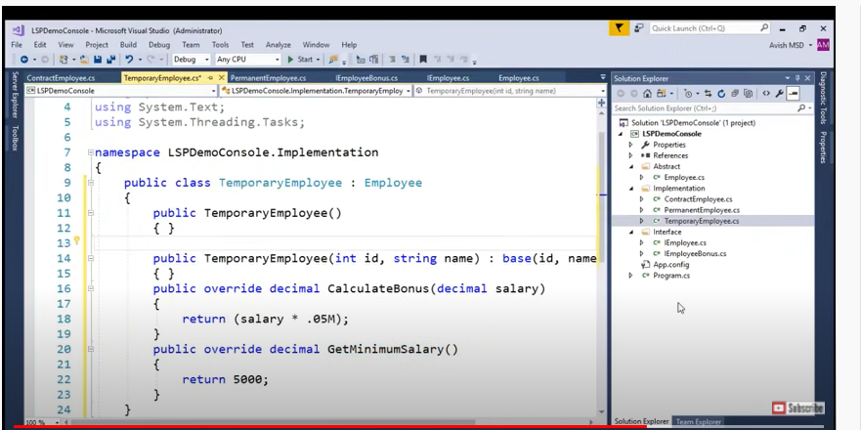

Conteact class see we are not inherting bonus

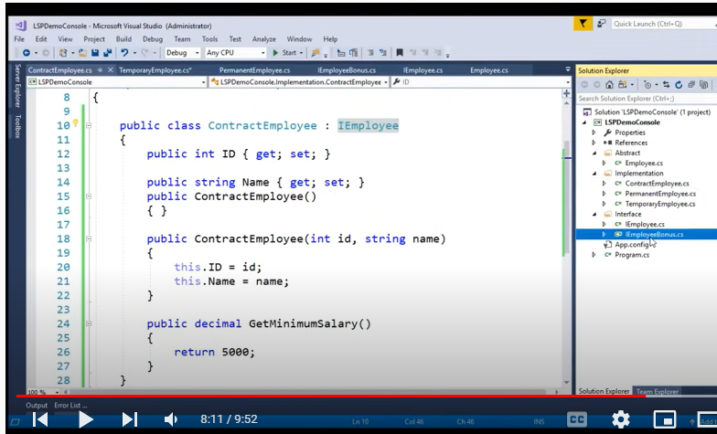

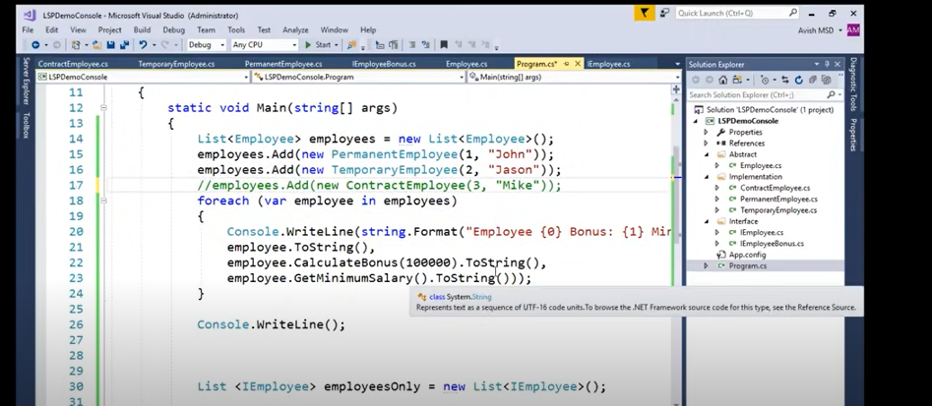

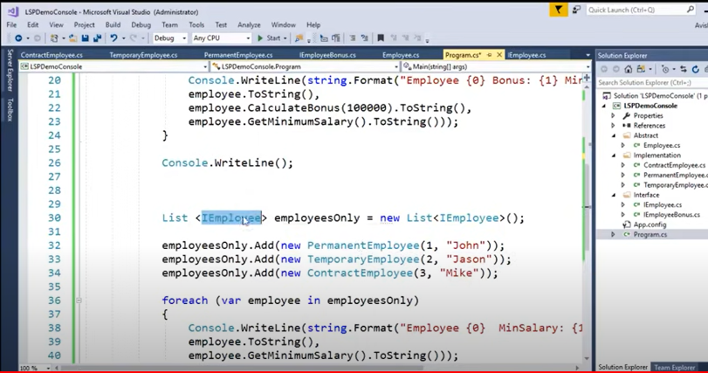

We have to creaye minisalry implementation for I Employee

Open closed principle

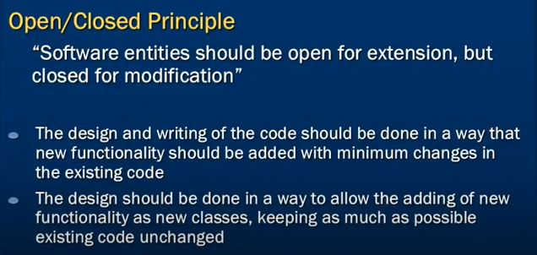

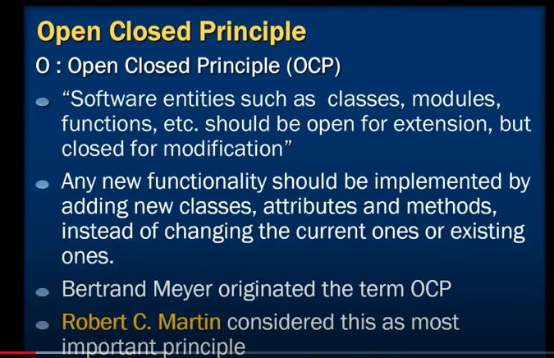

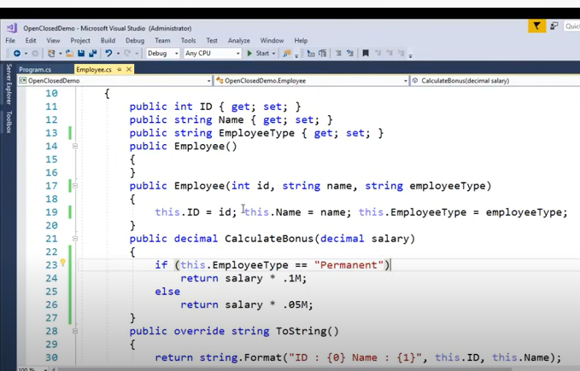

We have modifield class after coming new requirement of measure bonous for temp employee

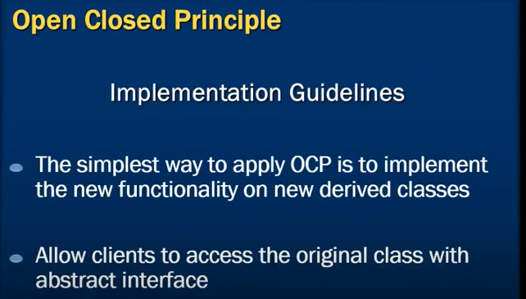

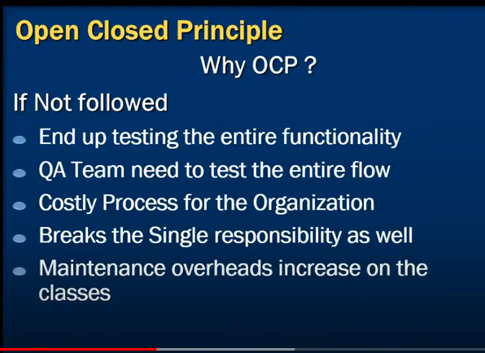

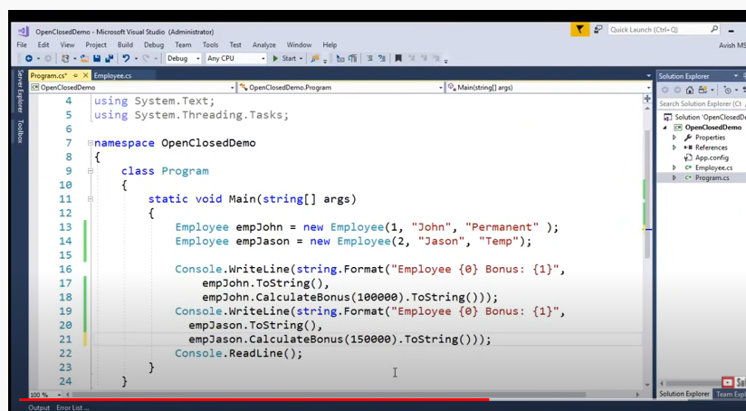

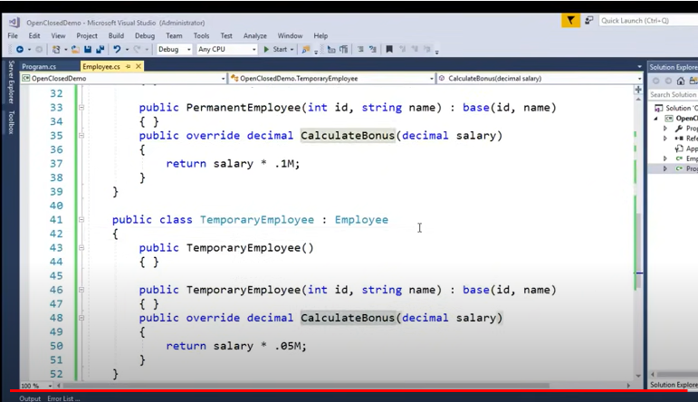

Interface segregattion principle:

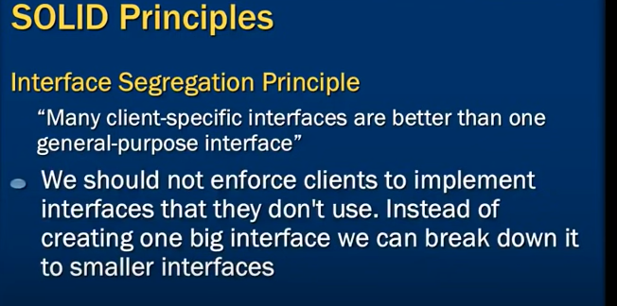

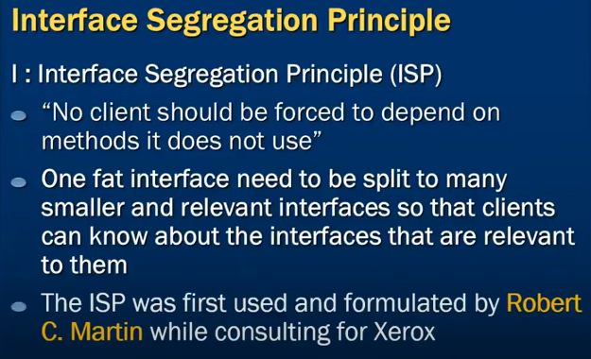

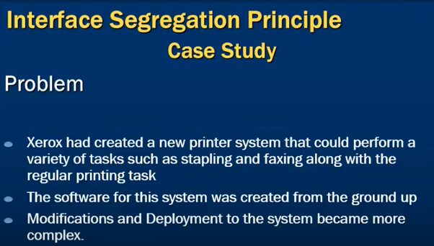

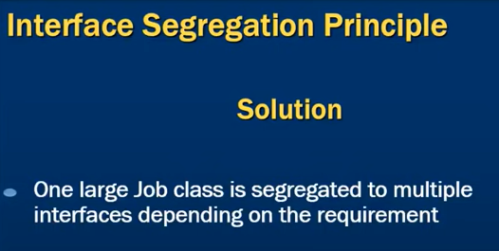

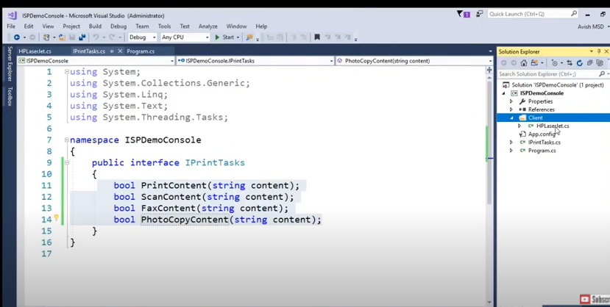

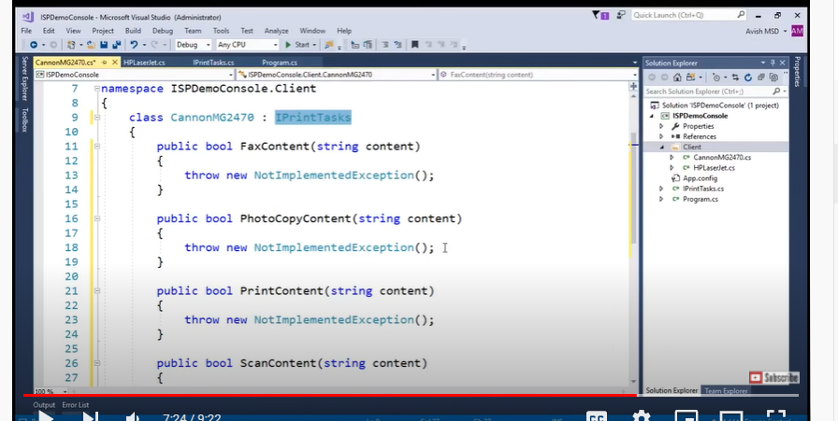

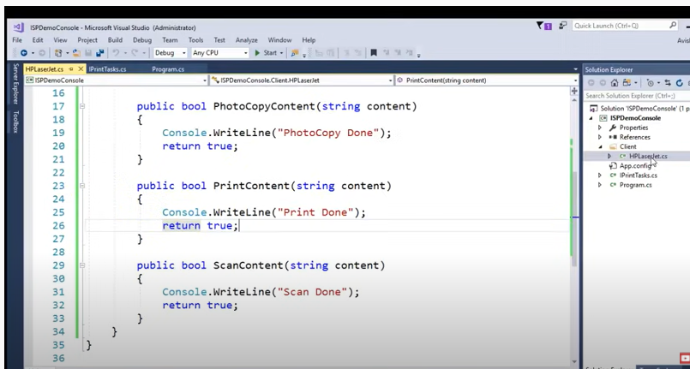

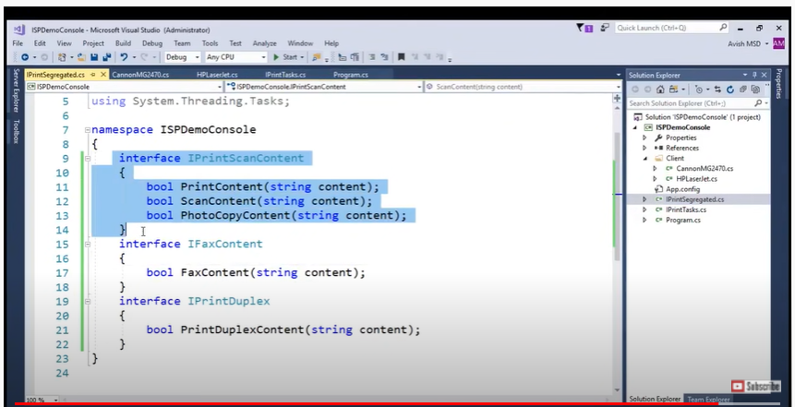

Dependency inversion principl:

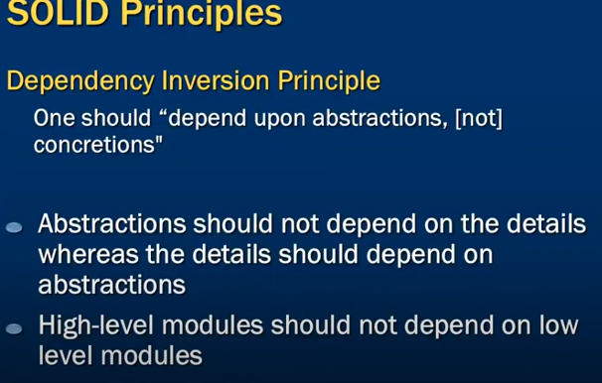

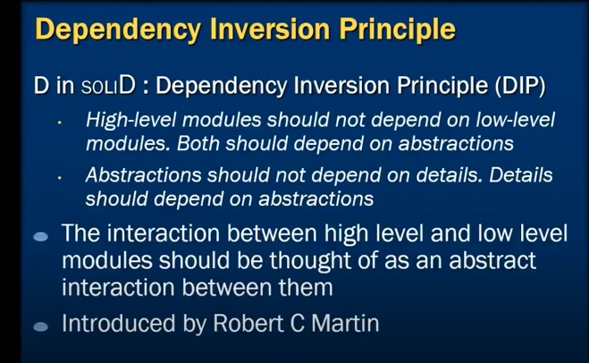

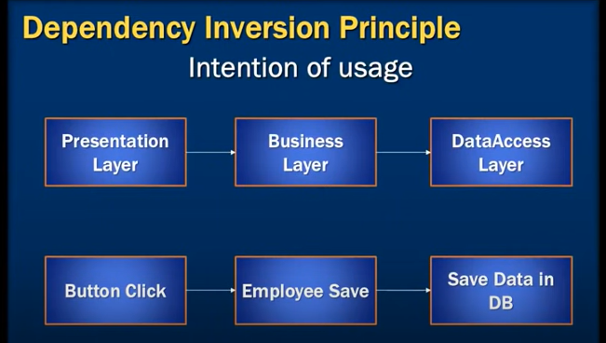

Problem 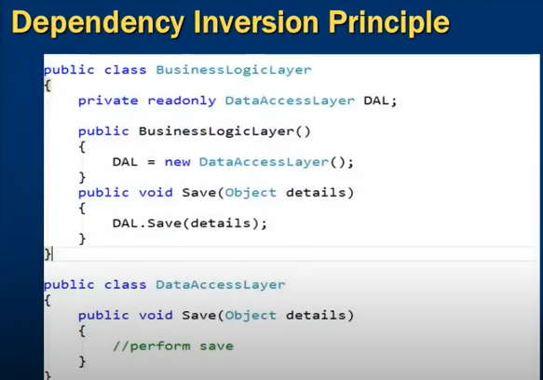

Solution:

HCL is providing SaaS based model solution. Mobile First solution is specifically designed to be centrally hosted on private cloud and services of this solution will be used by Kent and Essex police forces.

* The solution components will be hosted on a secure cloud environment. The hosting environment of the solution is provided by SunGard.
* Hosting environment data centres are hosted in United Kingdom.
* External system adaptors are developed and will be integrated with policing systems hosted in police network.
* Support services will be provided by HCL which will be discussed and agreed with force.
* This document will be updated when any changes are implemented which are outside the defined scope of Phase 1A delivery (see Section 2.2).

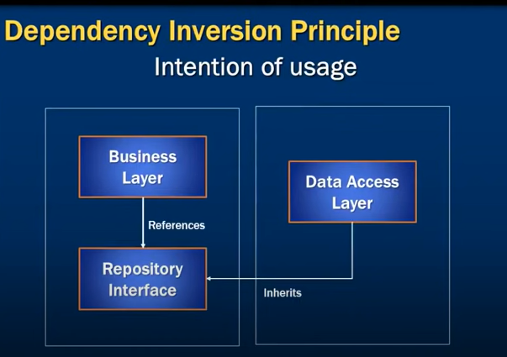

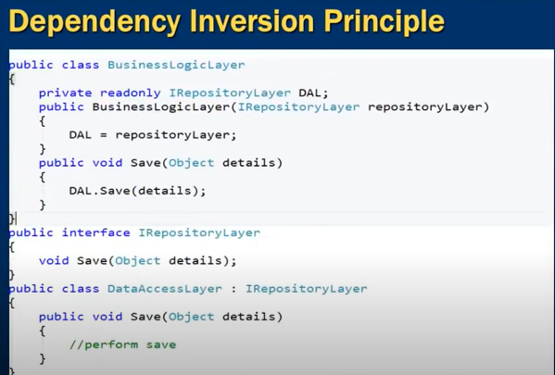

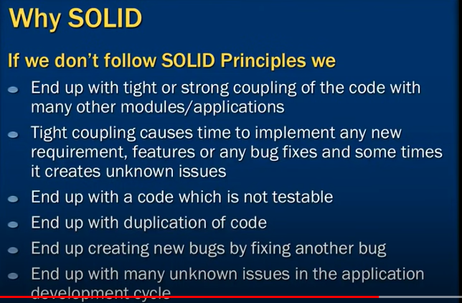

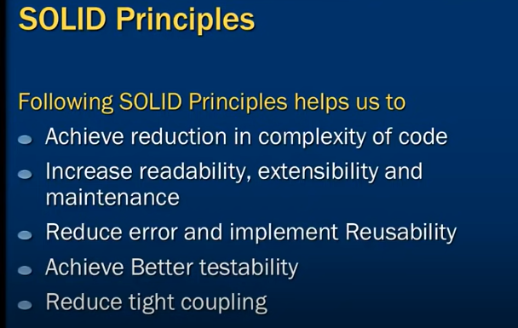

Design patterns

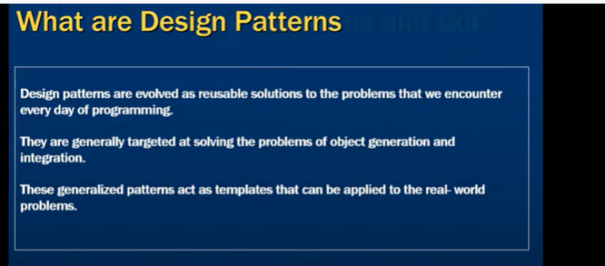

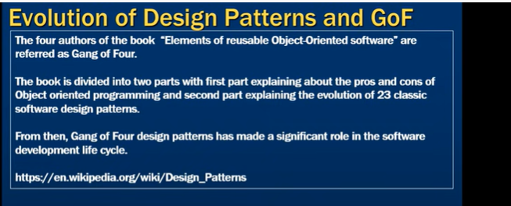

Types of design patterns:

Creational design pattern:

This is deal with object creation and initialization

Example: Abstract factory, singleton, factory

Structural design pattern:

This is deal with object composition. Simple word this pattern focus on decoupling interface and implementation of classes and its object

Example: Adaptor, bridge

Behavioral design patterns:

This is deal with the communication of object and classs

Example: command ,interpreter

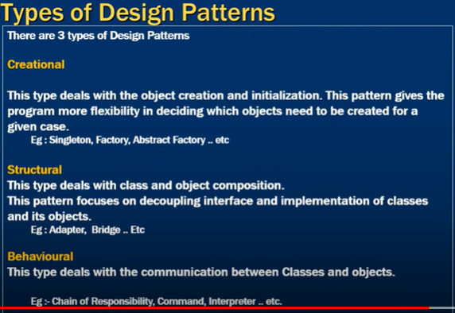

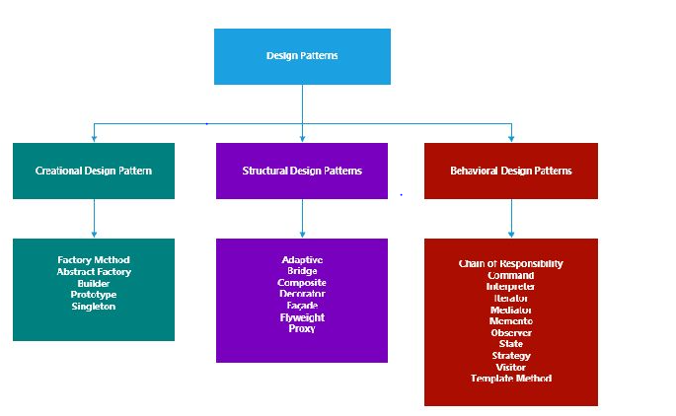

Singleton design pattermn:

Singleton design pattermn used When we need to ensure that only one object of a perticuar clsses is instantiated

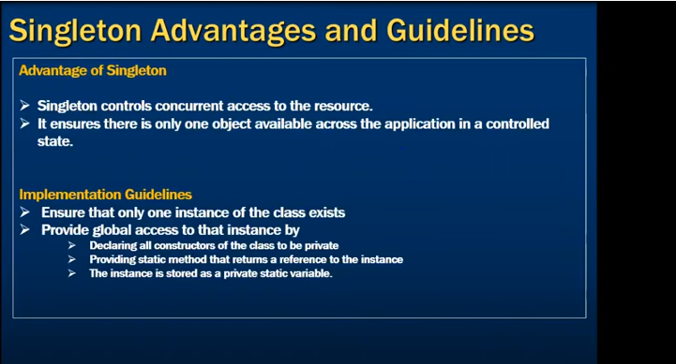

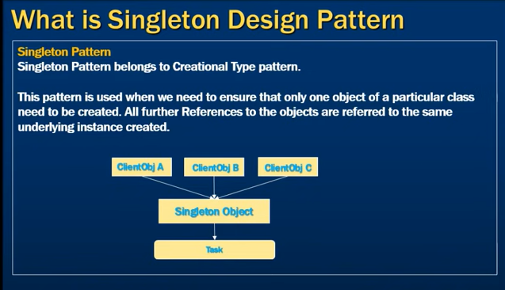

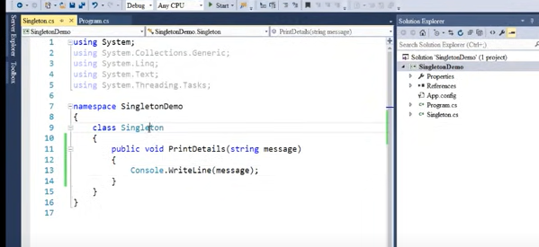

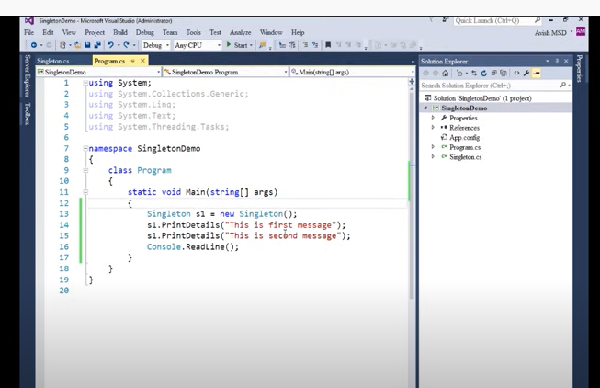

We have instanciated only one object and we are able to invoke printdetails methods

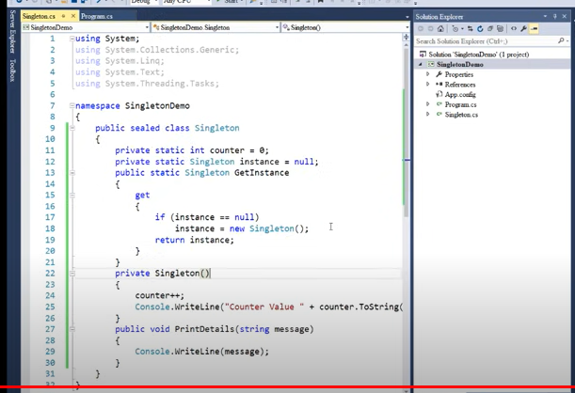

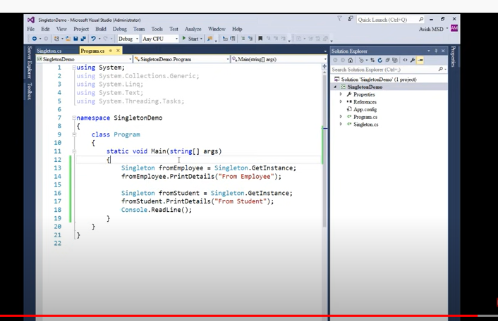

INTERVIEW questions

Following are the questions covered in this C# Q&A Series :-

- Questions on Stack, Heap, Boxing, Unboxing, Array, ArrayList, Generics, Threading.

00:00 Introduction.

02:34 Question 1 :- Explain difference between .NET and C# ?

.net is framework it is collection of libraries and it help you to run your .netor c# applications and c# is programing language .it has sysntaxes.grames,source code.by use of both we can crete applictions

06:44 Question 2 :- .NET Framework vs .NET Core vs .NET 5.0

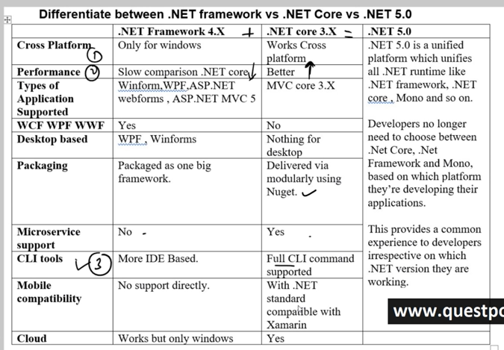

15:08 Question 3 :- What is IL ( Intermediate Language) Code ?

Partically compiled code

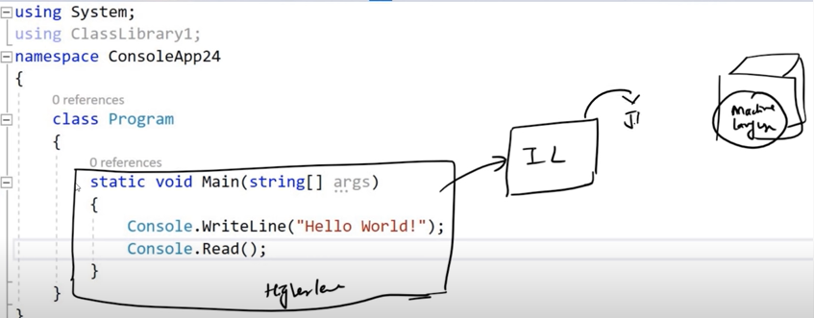

15:08 Question 4 :- What is the use of JIT ( Just in time compiler) ?

When you run the program ,JIT compiled IL code to machine language.

17:03 Question 5 :- Is it possible to view IL code ?

Yes it is possible by using assembler IL dASM or IL spy.

18:14 Question 6 :- What is the benefit of compiling in to IL code ?

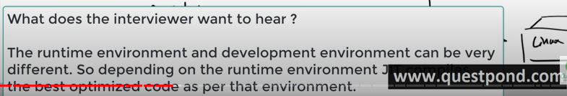

20:39 Question 7 :- Does .NET support multiple programming languages ?

yes

22:52 Question 8 :- What is CLR ( Common Language Runtime) ?

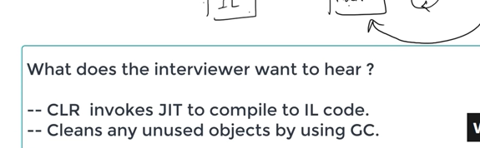

24:10 Question 9 :- What is managed and unmanaged code ?

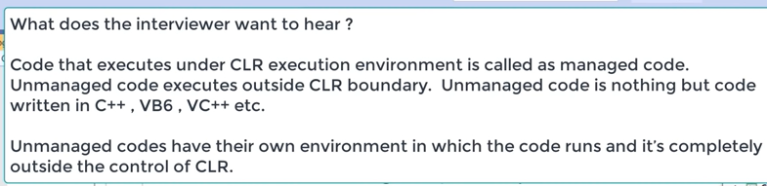

26:21 Question 10 :- Explain the importance of Garbage collector ?

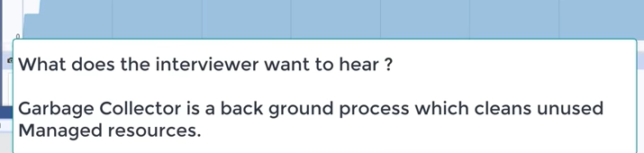

28:11 Question 11 :- Can garbage collector claim unmanaged objects ?

No,GC can not mangaer object outside the CLR runtime boundary

28:33 Question 12 :- What is the importance of CTS ?

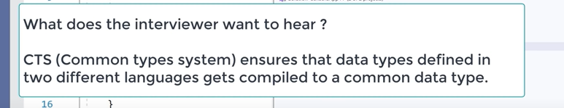

30:25 Question 13 :- Explain CLS ?

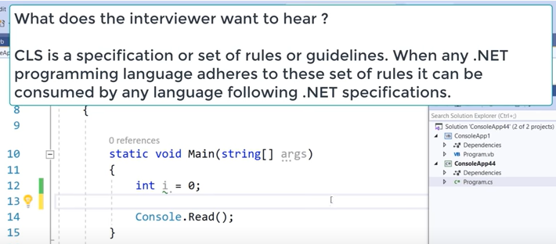

33:23 Question 14 :- Difference between Stack vs Heap ?

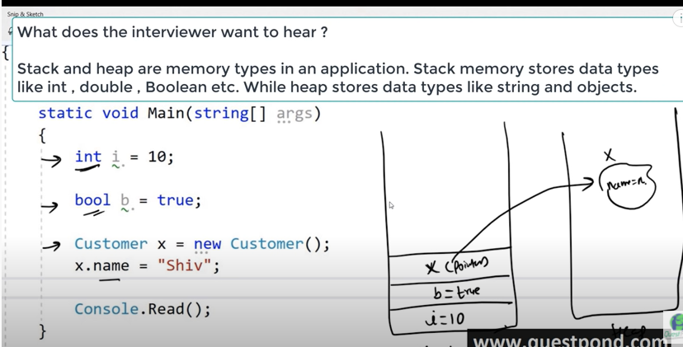

35:27 Question 15 :- What are Value types & Reference types?

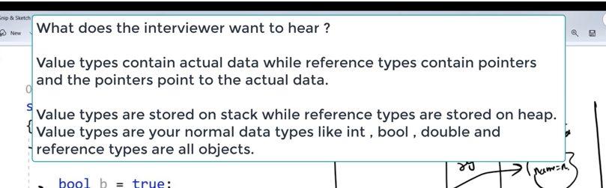

36:15 Question 16 :- Explain boxing and unboxing ?

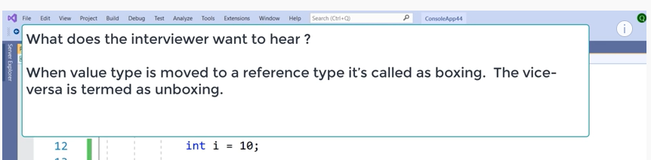

37:01 Question 17 :- What is consequence of boxing and unboxing ?

Perfermance implication while converting value typ to ref or vice versa.

37:32 Question 18 :- Explain casting,implicit casting and explicit casting ?

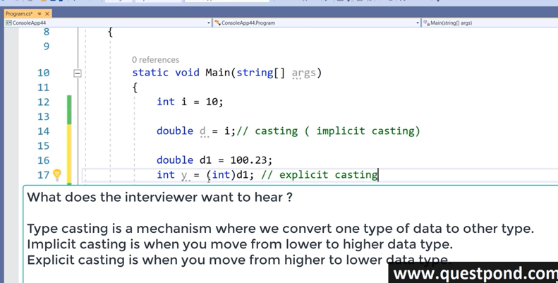

39:37 Question 19 :- What can happen during explicit casting ?

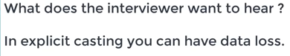

dataloss

40:48 Question 20 :- Differentiate between Array and ArrayList ?

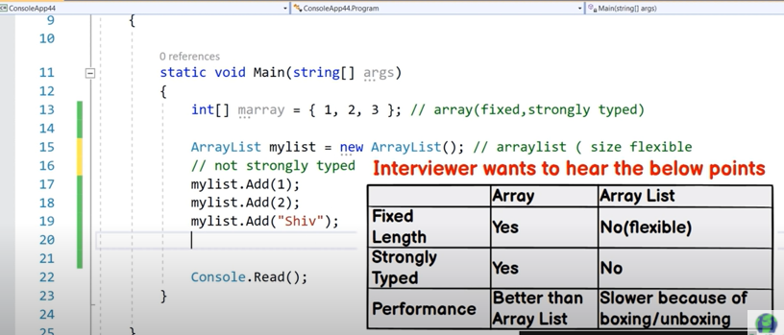

43:12 Question 21 :- Whose performance is better array or arraylist ?

Array performance is better

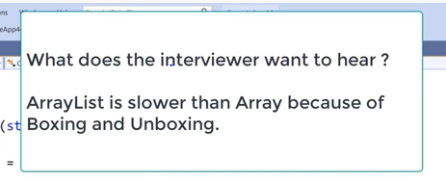

44:22 Question 22 :- What are generic collections ?

It takes all good things from array and arraylist.

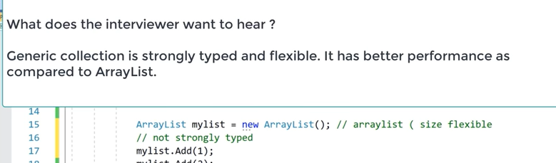

46:20 Question 23 :- What are threads (Multithreading)?

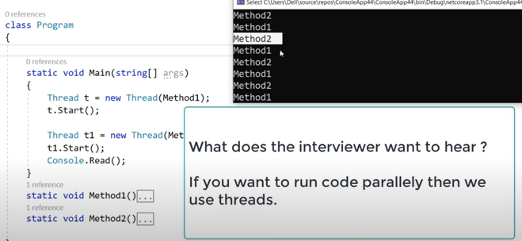

47:32 Question 24 :- How are threads different from TPL ?

Multithreading in C # is **a process in which multiple threads work simultaneously** . It is a process to achieve multitasking. It saves time because multiple tasks are being executed at a time. To create multithreaded application in C #, we need to use System.

TPL: 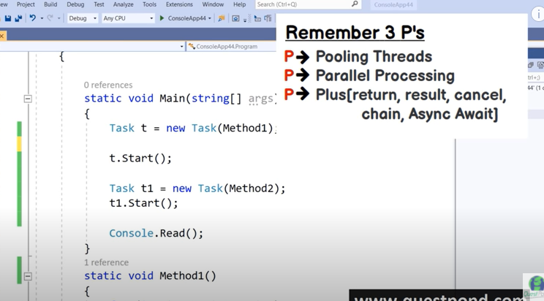

52:47 Question 25 :- How do we handle exceptions in C#(try/catch)?

Exception are halndles by try catch block,if do not have try catch block it just throw exceotion and it leaves it to application to handle it.

54:43 Question 26 :- What is the need of finally?

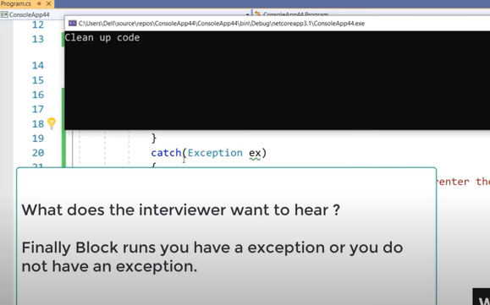

Finally block is used

55:49 Question 27 :- Why do we need the out keyword ?

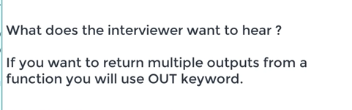

58:12 Question 28 :- What is the need of Delegates ?

58:45 Question 29 :- What are events ?

Events are rapper over deligates.

59:35 Question 30 :- Whats the difference between Abstract class and interfaceE ?

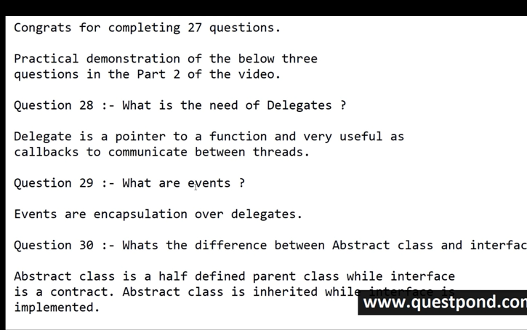

- Questions on Delegates, Event & Delegates vs Events.

Delgete is type safe function pointer.

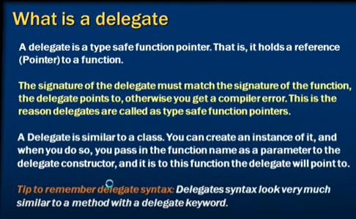

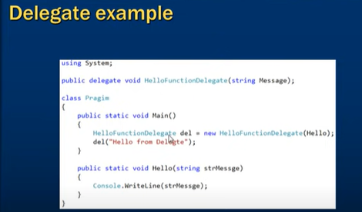s

Delegates **allow methods to be passed as parameters** . Delegates can be used to define callback methods. Delegates can be chained together; for example, multiple methods can be called on a single event. Methods do not have to match the delegate type exactly.

Question 31 - What is a Delegate and how to create a Delegate?

Question 32 - Where have you used Delegates?

Question 33 - What is a Multicast Delegates?

Question 34 - What is an Event?

Question 35 - How to Create an Event?

Question 36 - Delegate VS Events.

- Questions OOP, Abstraction, Encapsulation, Inheritance, Virtual, Overriding and overloading.

Question 37 :- Why do we need OOP ?

Question 38 :- What are the important pillars of OOPs ?

Question 39 :- What is a class and object ?

Question 40 :- Abstraction vs Encapsulation?

Question 41 :- Explain Inheritance ?

Question 42 :- Explain virtual keyword ?

Question 43 :- What is overriding ?

Question 44 :- Explain overloading ?

Question 45 :- Overloading vs Overriding ?

- Questions Polymorphism, Static vs Dynamic polymorphism and operator overloading.

Question 44 :- What is polymorphism ?

Question 45 :- Can polymorphism work with out inheritance ?

Question 46 :- Explain static vs dynamic polymorphism ?

Question 47 :- Explain operator overloading ?

- Tricky Questions around Abstract classes and Interfaces.

Question 48 :- Why do we need Abstract classes ?

Question 49 :- Are Abstract methods virtual ?

Question 50 :- Can we create a instance of Abstract classes ?

Question 51 :- Is it compulsory to implement Abstract methods ?

Question 52 :- Why simple base class replace Abstract class ?

Question 53 :- Explain interfaces and why do we need it ?

Question 54 :- Can we write logic in interface ?

Question 55 :- Can we define methods as private in interface ?

Question 56 :- If i want to change interface whats the best practice ?

Question 57 :- Explain Multiple inheritance in Interface ?

Question 58 :- Explain Interface Segregation principle ?

Question 59 :- Can we create instance of interface ?

Question 60 :- Can we do Multiple inheritance with Abstract classes ?

- Answering the most asked Question "Abstract classes vs Interface".

Abstract Class vs interface interview questions and answers.

- Questions around constructors & in parent child which constructor fires first.

Question 62 :- Why do we need constructors ?

Question 63 :- In parent child which constructor fires first ?

Question 64 :- How are initializers executed ?

Question 65 :- How are static constructors executed in Parent child ?

Question 66 :- When does static constructor fires ?

- Questions around Shadowing, Sealed, Nested classes and partial classes.

Henkel

AO Migration - Data Web Applications

Project is closed

Posted Aug 25, 2021

Project ID: 2733360

SIGN UP FOR NEW OPPORTUNITIES

Location

Remote , Remote

Duration

3 months

(Sep 1, 2021 - Nov 30, 2021)

Hours/week

40 hrs/week

Payrate range

Unknown

*\*Please note: the service contract for this position will not be concluded with Henkel AG & Co. KGaA but with an external party”.*

**Project name: AO Migration**

**Project description / Background to the assignment**

As part of the AO Migration project, we plan 4 supply chain related products. This includes, among other things, the (further) development of software “Supply Chain Digital Twin Frontend” for the purpose of interactively visualization of the Supply Chain Digital Twin and supports quick scenario analyses with financial impacts. The development also requires the development of components “Make or Buy (MoB)” and “Network Graph” contained in the software. The latter must be carried out in the programming languages Angular, HTML/ CSS, JavaScript and jQuery, in order to maintain compatibility with older versions of the software Supply Chain Digital Twin Frontend. However, the programming languages Angular, HTML/ CSS, JavaScript and jQuery has no relevance for the core products. Consequently**, we do not have our own employees with sufficient expertise**in connection with the programming languages Angular, HTML/ CSS, JavaScript and jQuery and for this reason requires external expertise. The contractor used by us has extensive experience with projects that require development services in the programming languages Angular, HTML/ CSS, JavaScript and jQuery, **therefore the contractor has a unique position and provides significantly different services** than the internal staff

**Task Description**

The services shall be provided within the framework of an agile development method. The concrete activities required in each case to implement the services commissioned shall be agreed iteratively between the parties within the framework of sprint meetings and implemented by the Contractor within the respective sprints following the sprint meetings. Prior to each sprint meeting, the **contractor shall independently** **check**, **on the basis of its professional expertise**, which individual services are reasonable and feasible within the scope of the assignment in the respective sprint. The **sprints**each have a duration of 2 weeks, so that the **sprint meetings**take place at intervals of **2 weeks**. Within the individual sprints, the contracting parties shall coordinate the respective technical requirements for the services to be provided in **daily meetings**in order to achieve the compatibility of the individual components Supply Chain Digital Twin. The technical requirements for the services to be provided **are assessed by the Contractor on the basis of its own technical assessment**. After completion of a Sprint, the parties shall conduct a "Sprint Review'' in which the contractor reports on the feasibility and status of the services performed by it in the previous sprint and makes a recommendation on how to proceed with regard to the services that proved to be unfeasible in the respective sprint. All of the meetings and exchanges described above shall take place exclusively in the presence of a central contact person named by us, who shall coordinate the project on our internal side. The organisation and scheduling of the meetings described above in which the contractor is involved shall be organised and carried out by the contractor and coordinated with us.

Backlog items will be assigned in Azure DevOps containing business requirements and acceptance criterias.

Tasks:

* Affiliation of scalable and responsive Microsoft Azure cloud-based Web application using state-of-the-art frontend engineering practices by
  + Designing a technical concept according to the backlog item
  + Designing responsive UX designs end according to the backlog item
  + Designing APIs
  + Developing and implementation of the aforementioned technical concept and UX designs
  + Testing including unit and functional tests, in case of identified bugs or issues the task is to rework it from step 1. The documentation will be done in Azure DevOps / ServiceNow and approved by Henkel.
* Affiliation of scalable either schedules or by frontend called Microsoft Azure cloud-based data bases and back-end pipelines using state-of-the-art data engineering practices by
  + Designing a technical concept and data models according to the backlog item
  + Designing APIs
  + Developing and implementation of the aforementioned technical concept and UX designs
  + Testing including unit and functional tests, in case of identified bugs or issues the task is to rework it from step 1. The documentation will be done in Azure DevOps / ServiceNow and approved by Henkel.
* Implement security and data protection settings according to backlog item
* Identify, design, and implement product improvements for the project related tasks according to the discussed backlog
* Documentation of technical implementation and related processes in Azure DevOps. Henkel will validate and approve it.